***www.christianworldmissions.org***

**FEBRUARY 2015**

**Prayer Notes & Ministry Opportunities:**

February 4

MUW Wesley Foundation

Columbus MS

Lee Ann Williamson, guest speaker

February 20 – 6:30 am

CWM Leadership Council   
Monthly Meeting, Starkville Café

March 14   
Lee’s Summit, MO

Grace UMC, Luncheon & Concert

March20Sedalia MO, 1st UMC

Women’s Night

March 21

The Big Event

Maroon Volunteers

March 22

Southaven UMC

Morning Concert

March 28   
Poplarville MS

1st UMC

Evening Concert

**Weekly Local Ministries:**

Sun, 5:15pm – 6:45pm  
Home Bible Study – Starkville   
Lee Ann Williamson, leader

Fri, 6:30am – 7:30am   
Men’s Prayer Breakfast   
Cecil Williamson, host

CWM Outreach Center

**Monthly Community Outreach:**

CWM Outreach Center

February 21 – Celebrating Relationships

**Pray For Our International Partners:**

Feb – Mar – J.K. Udeze in Nigeria and Joseph Otsin in Ghana – conducting follow-up training for lay pastors and visiting all recently established churches

See our website for event details:

<http://www.christianworldmissions.org/news-and-events/ministry-eventsmissions/>

*To schedule a ministry event, order resources or join us on a mission trip:*

*Contact:*

[*leeann@christianworldmissions.org*](mailto:leeann@christianworldmissions.org)

[*lori@christianworldmissions.org*](mailto:lori@christianworldmissions.org)

[*info@christianworldmissions.org*](mailto:info@christianworldmissions.org)

[*cecil@christianworldmissions.org*](mailto:cecil@christianworldmissions.org)

Do you know how much we appreciate you? Simply put, we couldn’t reach a person in the world if you weren’t helping us. I love the way *The Message* interprets Paul’s letter to the church in Philippi:

*I do want you to experience the blessing that issues from your generosity. The gifts you sent were more than enough, like a sweet-smelling sacrifice roasting on the altar, filling the air with fragrance, pleasing God no end. (Philippians 4:17-18)*

So, here are a couple of blessings for you to experience right now!

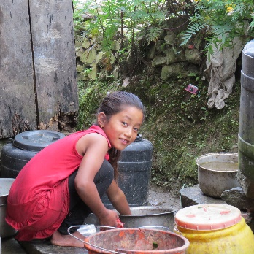

This precious daughter was a “groupie” on our visit to the highest spot of our Nepali mission in October, the village of Deurali. Chori tripped down the path with us, curious about the foreigners who had come, but she discovered much more when she opened her heart to Jesus! She not only helped to prepare our lunch after the service, she is pictured here cleaning the large cooking vessels that were used for our feast.

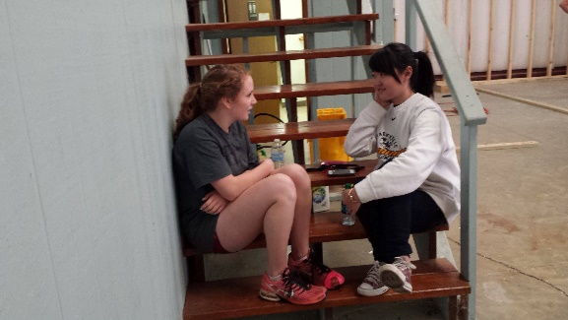In January, we played host to volunteer teams on Martin Luther King, Jr. Day. About 30 adults and teens helped with clean-up and construction projects. During our lunch break, I happened to overhear the conversation between these two lovelies – one sharing the Good News of Jesus with the other. I almost danced a jig! Our mission was being fulfilled by a volunteer we had only just met!

We are so happy to call you partner in the Lord. Thank you!

Blessings,

