Prayer Notes & Ministry Opportunities:

Friday, April 1, 6 pm
Concert, “From the Cross to Pentecost”
Louisville, MS, Betheden Lutheran Church

Saturday, April 11
Prison Outreach (Cecil Williamson)
Parchman, MS

Thursday, April 16, 11 am – 1 pm
Health Fair hosted by Legacy Hospice
CWM Outreach Center, Starkville, MS
April 17-19
Aldersgate Youth Retreat
Camp Wesley Pines
Hazelhurst, MS

Saturday, April 25, 1-4 pm
Straight-Up Saturday
Monthly Neighborhood Outreach
CWM Outreach Center, Starkville, MS

Sunday, April 26, 5 pm
Concert, “From the Cross to Pentecost”
First United Methodist Church
Starkville, MS

Thursday, May 14, 6:30 pm
“A Night Under the Stars”
Musical Dinner Theatre
CWM Outreach Center, Starkville, MS

Friday, May 15, 7:30 pm
“A Night Under the Stars”
Musical Review (Program only)
CWM Outreach Center, Starkville, MS

Saturday, May 16
Straight-Up Saturday
Monthly Neighborhood Outreach
CWM Outreach Center, Starkville, MS

Weekly Local Ministries:
Mon, 5:30pm –7:30 pm
Home Bible Study – Starkville
Lee Ann Williamson, leader
Fri, 6:30am – 7:30am
Men’s Prayer Breakfast
Cecil Williamson, host
CWM Outreach Center

Looking for a Mission Opportunity?
Join one of our International missions, or
Gather a team and join us for a week of construction in our Outreach Center!

See our website for event details:
http://www.christianworldmissions.org/news-and-events/ministry-eventsmissions/

To schedule a ministry event, order resources or join us on a mission trip:

Contact:
leeann@christianworldmissions.org
lori@christianworldmissions.org
info@christianworldmissions.org
cecil@christianworldmissions.org

www.christianworldmissions.org

April 2015

Happy Spring! Aren’t you glad to see the warm weather return, and with it, the celebration of the Lord’s resurrection and the gift of the Holy Spirit! This is my favorite time of year. “Behold! All things are made new!!!”

I’m usually in Africa this time of year, but this year, with the Ebola outbreak and continual violence in Nigeria from Boko Haram, we felt it best to let our African partners carry-on with the planned training events without us.
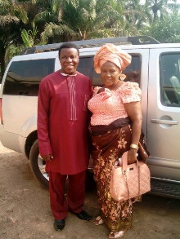
Already, the program has been delayed because of violence surrounding national elections in Nigeria. Please pray for the 3000 church leaders who will gather May 4-11 to be led by our own Sir JK Udeze (pictured with his wife, Helen) and others in “crusades, seminars, teachings and empowerment sessions.” Where sin abounds grace does MUCH MORE abound!

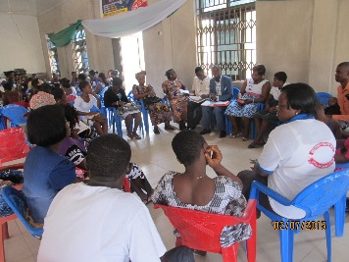
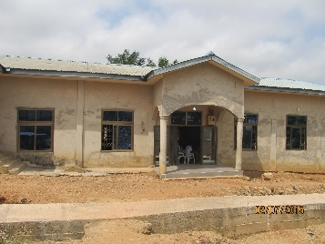
In Ghana, Evan. Joseph Otsin sent pictures of the follow-up conducted last month with churches that were planted 2 years ago. Many are thriving, with active youth ministries, Bible studies, and prayer ministry. They have also been able to finish the walls for pavilions which you helped to provide, such as this one in Adowato.

Continue to pray for all of the 450+ churches you have established in Africa. God is raising up a new generation of believers who will continue to spread the Good News to that great continent. Surround your brothers and sisters in Ghana and Nigeria with prayer and love.

We can’t say it often enough or too many times! Thank you for reaching out across the world to share God’s love. You are a blessing!

Smiling and thanking Jesus,

