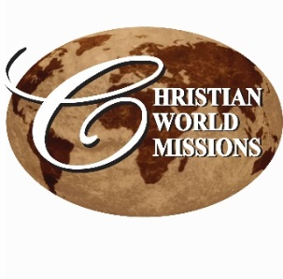

P.O. Box 985, Starkville, MS 39759

**Prayer Notes & Ministry Opportunities:**

**JUNE**

Thursday – Saturday, June 4 – 6

MS Annual Conference

Jackson, MS

Sunday, June 7 – 10 5:30 pm

Vacation Bible School

Missions: Nepal Earthquake

FUMC Starkville

Monday, June 8

IGNITE begins!

Every Mon & Tues 1pm; Thurs 11am

Youth Community Explosion YCE

Summer Community Youth Ministry

CWM Outreach Center, Starkville, MS

Sunday, 14, 21, & 28 9:45qm

Lee Ann Teaching Bible Class

Sandtown UMC

Philadelphia, MS

Friday, June 19 6:30am – 8:00am

CWM Leadership Council Meeting

Starkville Café

Friday, June 26 6:00pm

CWM Advisory Council Meeting

At Home of Lee Ann & Lori

205 Winterset Dr, Starkville, MS

Saturday, June 27 9:00am

CWM Council Meeting

CWM Outreach Center, Starkville, MS

Saturday, June 27 4:00pm – 8:00pm

Straight-Up Saturday

Monthly Neighborhood Outreach

CWM Outreach Center, Starkville, MS

**Weekly Local Ministries:**

June 8 – July 24

IGNITE! 6-8th grade youth

Mon & Tues – 1-4 pm, CWM Center

Thurs, various times, service & field trips

Thurs, 5:30pm –7:30 pm  
Home Bible Study – Starkville   
205 Winterset Dr., Starkville

Fri, 6:30am – 7:30am   
Men’s Prayer Breakfast   
Cecil Williamson, host

CWM Outreach Center

**Looking for a Mission Opportunity?**Join one of our International missions, or

Gather a team and join us for a week of construction in our Outreach Center!

See our website for event details:

<http://www.christianworldmissions.org/news-and-events/ministry-eventsmissions/>

*To schedule a ministry event, order resources or join us on a mission trip:*

*Contact:*

[*leeann@christianworldmissions.org*](mailto:leeann@christianworldmissions.org)

[*lori@christianworldmissions.org*](mailto:lori@christianworldmissions.org)

[*info@christianworldmissions.org*](mailto:info@christianworldmissions.org)

[*cecil@christianworldmissions.org*](mailto:cecil@christianworldmissions.org)

**June 2015**

Hold onto your hat! The Wind’s blowing at CWM! The wind of the Holy Spirit, that is!

**New things are happening!**

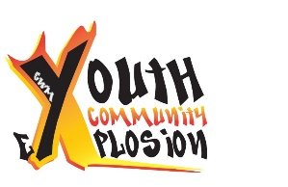

**NORTH STARKVILLE:** Beginning June 8, our first-ever local youth outreach begins! For 7 weeks, youth in grades 6-8 will explore the Word of God, make field trips to the university and museums, and serve others in the community. This week, the boys have already been showing up, playing basketball in the gym and helping us with clean-up in preparation for the start. I can’t wait to see how God impacts their lives!

**How you can help:**

* **Pray!** Life for these youth has many challenges. Only Christ can make a lasting difference and give them hope & a future!
* **Give!** We’re offering this program free of charge, and the youth will have 2 fund raisers during the session. We need snacks, study materials (Bibles, too!), transportation (we’d love a 15 passenger van or small bus), and air conditioning in the gym!

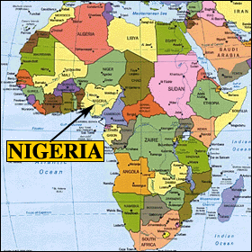**NIGERIA:** Sir J.K. Udeze has just sent the report from the 2015 Gospel Crusade and Leadership Training in Mgbo Diocese where we planted 10 churches in 2013. The largest now has 180 members, and the smallest, Amorie, has only 13. In 2014, we planted 10 churches in Osogbo state. They now range in membership from 35 to 11.

**How you can help:**

* **Pray!** Islam is on the rise, particularly in Osogbo, and the economy has forced 35 members to migrate to other areas. Pray for these young believers to stand strong in God’s promises!
* **Give!** 8 churches still meet in the open air or homes, and 4 are in school rooms. Only $2500 gives them a pavilion!