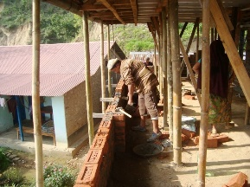**NEPAL:** Thanks to the help of our local church, Starkville First United Methodist, and several other supporters, we have been able to supply financial aid to our partners in eastern Nepal. Much of the aid has been directed to Kathmandu and areas closer to the epicenters of the 3 largest earthquakes. It is essential that organizations like ours step up to help in other remote areas. This picture shows one of several houses that are being repaired. Churches are not even on the radar of the government aid of this Buddhist nation, so we are also helping to rebuild several damaged churches.

**How you can help:**

**Pray!** While you might expect Christians to focus on rebuilding their homes and churches, our partners are already moving out to meet the needs of others. Quite a few have come to Christ as they experience God’s love through these precious ones. Pray for open hearts!

**Give!** Thousands are still living in unsafe homes and are in need of supplies for food, clean water, and rebuilding. We will help as much as we are able.

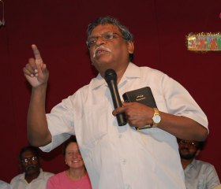**INDIA:** Ghuna Kumar, our partner with Gospel Friends, was recently with us for one day. We were thrilled to hear about the new Bible study he has written to help believers around the world have a thorough understanding of God’s plan to make His people holy. Ghuna reminded us of the vital importance of evangelism in these days!

**How you can help:**

**Pray!** Gospel Friends baptizes thousands of new believers each year, bringing them into churches, providing education, housing, and training for economic opportunities.

**Give!** The monthly needs of this vast ministry are great. Please help us to help them with their on-going support of widows, orphans, pastors, and students.

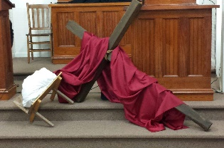**RIGHT HERE AT HOME:** I frequently hear the question, “How do you keep up with everything?” Only with the strength, help, and provision of the Lord! This photo comes from our Lenten Concert series, which was a powerful walk through the life of Christ in song and scripture. Only Jesus, all the time, and that is enough.

**How you can help:**

**Pray!** We are now a staff of six! Three come to us through grant funds, and we are grateful! We have the sweetest fellowship, and all are anointed in their respected work.

**Give!** The needs of CWM are growing daily, as the ministry grows. Please help us to be able to continue to reach out in His name!

Soaring on Eagle wings,

