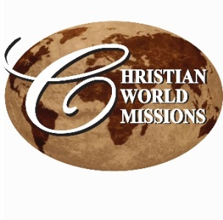
IPrayer Notes & Ministry Opportunities:

AUGUST

WEEKLY LOCAL MINISTRIES:
Wednesday, beginning Aug. 19, 5:45 pm
Bible Study: “Living Life by Faith in Him,” Lee Ann & Jean Ferguson
1st UMC Starkville, 5:45 pm

Thursday, beginning Aug. 20, 6:30 pm
Home Bible study, Lee Ann
205 Winterset, Starkville
The Minor prophets, 6:30 pm

Friday, 6:30 am
Men’s Prayer Breakfast
CWM Outreach Center, Cecil Williamson

Daily, Mon – Thurs, Beginning Sep 28
3:30 – 6:30 pm, 6-8th graders,
Youth Community Explosion,
CWM Outreach Center

Tuesday, beginning Sep 29, 6:30 pm
For parents of YCE program and others
Parent 2 Parent
CWM Outreach Center

UPCOMING
SEPTEMBER: Training of 20 new pastors begins in GHANA AND NIGERIA in advance of church planting program in Feb/Mar 2016

Nov 29 – December 23 –
Lee Ann & Lori offering Christmas concerts; don’t wait! Book yours now!

Looking for a Mission Opportunity?
Join one of our International missions, or Gather a team and join us in completing the construction in our Outreach Center!

See our website for event details:
http://www.christianworldmissions.org/news-and-events/ministry-eventsmissions/

To schedule a ministry event, order resources or join us on a mission trip:

Contact:
leeann@christianworldmissions.org
lori@christianworldmissions.org
info@christianworldmissions.org
cecil@christianworldmissions.org

P.O. Box 985, Starkville, MS 39759

July 2015

Traveling and teaching,
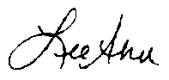
Lee Ann Williamson

